17. Design TM using simulator to accept the input string Palindrome “ababa”

AIM: To design TM using simulator to accept the input string Palindrome ababa

TRANSITION DIAGRAM:

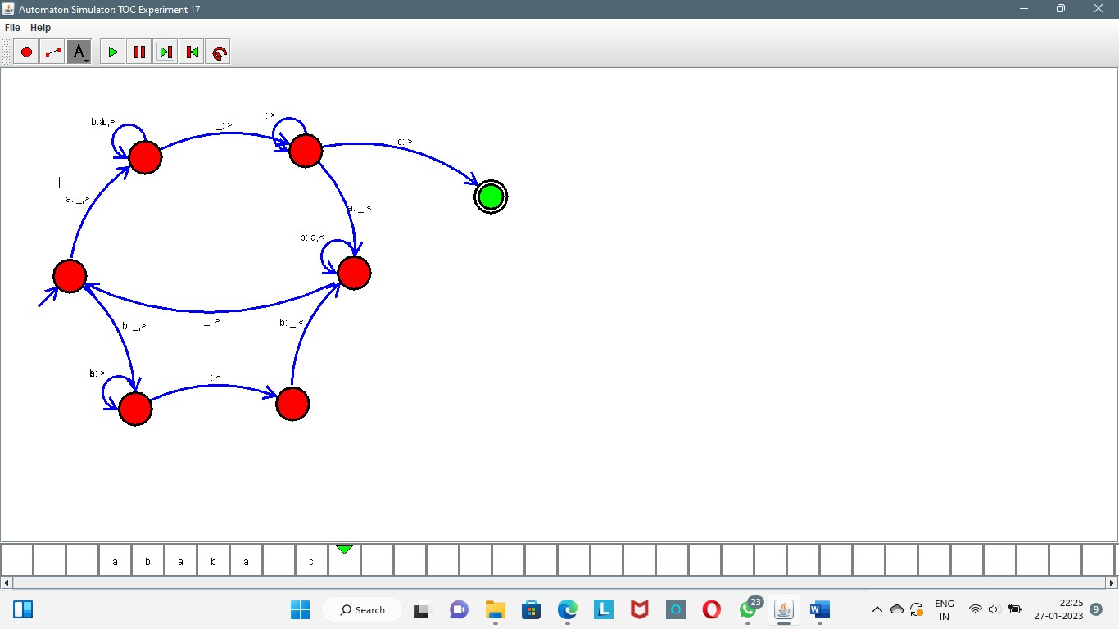

RESULT: The TM is designed to compute the string given as input using a simulator.